* **Activity 7:**

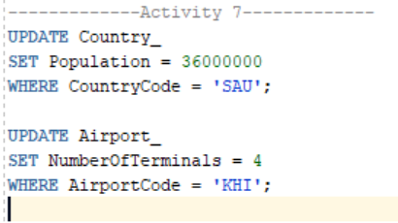Updating Rows in a Table

OUTPUT:

